PLANCK’S CONSTANT IN THE LIGHT OF AN INCANDESCENT LAMP
SOLUTION

TASK 1

Draw the electric connections in the boxes and between boxes below.

Pm
B
Ω
V
A
P
Photoresistor

Incandescent Bulb

Potentiometer

Red socket

Black socket

Ohmmeter

Ω

Voltmeter

V

Ammeter

A

Platform

P

Potentiometer

Pm

Battery

B

TASK 2
a)
t₀ = 24 ºC | T₀ = 297 K | ΔT₀ = 1 K

b)
V /mV | I / mA | R_{B} /Ω
21.9  30.5  34.9  37.0  40.1  43.0  47.6  51.1  55.3  58.3  61.3  65.5  67.5  73.0  80.9  85.6  89.0  95.1  111.9  130.2  181.8  220  307  447  590  730  860  960 | 1.87  2.58  2.95  3.12  3.37  3.60  3.97  4.24  4.56  4.79  5.02  5.33  5.47  5.88  6.42  6.73  6.96  7.36  8.38  9.37  11.67  13.04  15.29  17.68  19.8  21.5  23.2  24.4 | 11.7  11.8  11.8  11.9  11.9  11.9  12.0  12.1  12.1  12.2  12.2  12.3  12.3  12.4  12.6  12.7  12.8  12.9  13.4  13.9  15.6  16.9  20.1  25.1  29.8  33.9  37.1  39.3

V_{min} = 9.2 mV *

* This is a characteristic of your apparatus. You can´t go below it.

We represent R_{B} in the vertical axis against I.

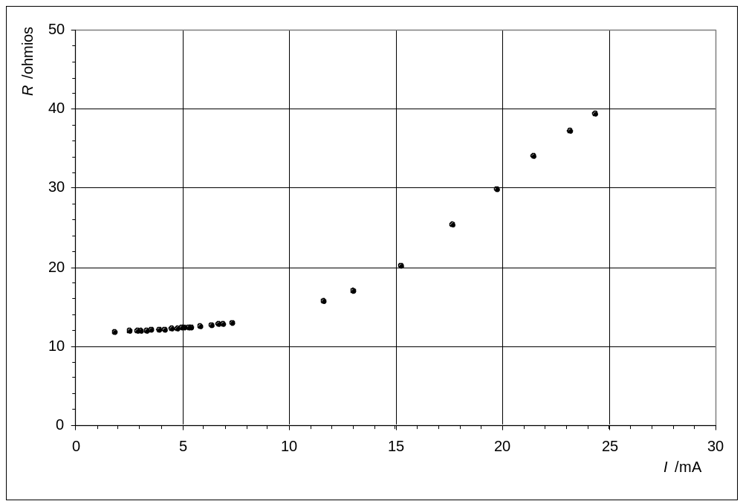

In order to work out R_{B0} , we choose the first ten readings.

TASK 2

c)

V /mV | I / mA | R_{B} /Ω
21.9 ± 0.1  30.5 ± 0.1  34.9 ± 0.1  37.0 ± 0.1  40.1 ± 0.1  43.0 ± 0.1  47.6 ± 0.1  51.1 ± 0.1  55.3 ± 0.1  58.3 ± 0.1 | 1.87 ± 0.01  2.58 ± 0.01  2.95 ± 0.01  3.12 ± 0.01  3.37 ± 0.01  3.60 ± 0.01  3.97 ± 0.01  4.24 ± 0.01  4.56 ± 0.01  4.79 ± 0.01 | 11.7 ± 0.1  11.8 ± 0.1  11.8 ± 0.1  11.9 ± 0.1  11.9 ± 0.1  11.9 ± 0.1  12.0 ± 0.1  12.1 ± 0.1  12.1 ± 0.1  12.2 ± 0.1

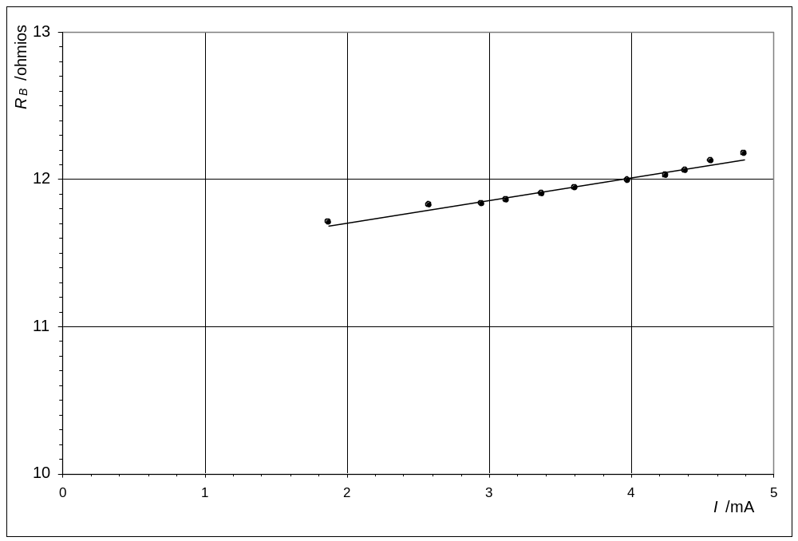

Error for R_{B} (We work out the error for first value, as example).

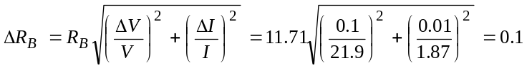

We have worked out R_{B0} by the least squares.

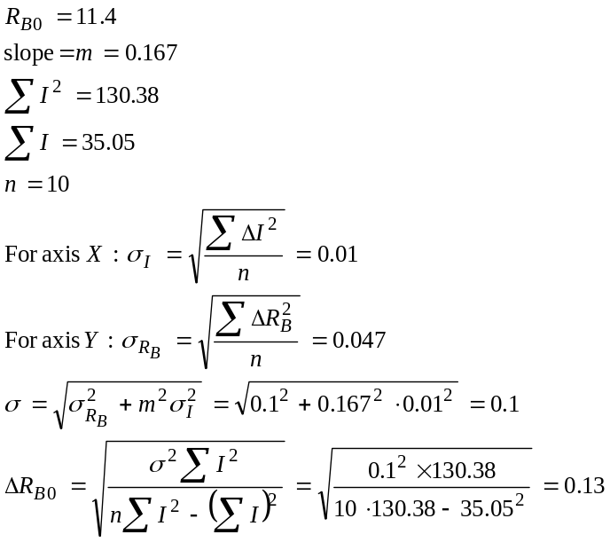

R_{B0} = 11,4 Ω | Δ R_{B0} = 0.1 Ω

d) 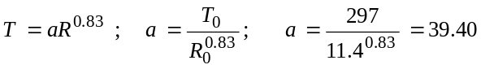

Working out the error for two methods:

Method A
Method B

Higher value of a: 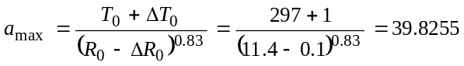
Smaller value of a: 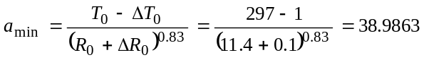

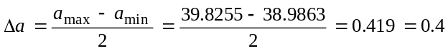

a = 39.4 | Δa = 0.4

TASK 3

Because of 2Δλ = 620 – 565 ; Δλ = 28 nm

λ₀ = 590 nm | Δλ = 28 nm

TASK 4
a)
V /V | I / mA | R /kΩ
9.48  9.73  9.83  100.1  10.25  10.41  10.61  10.72  10.82  10.97  11.03  11.27  11.42  11.50 | 85.5  86.8  87.3  88.2  89.4  90.2  91.2  91.8  92.2  93.0  93.3  94.5  95.1  95.5 | 8.77  8.11  7.90  7.49  7.00  6.67  6.35  6.16  6.01  5.77  5.69  5.35  5.17  5.07

b)

Because of

For working out Δγ we know that:
R ± ΔR = 5.07 ± 0.01 kΩ
R’ ± ΔR’ = 8.11 ± 0.01 kΩ
Transmittance, t = 51.2 %
Working out the error for two methods:

Method A

Method B
Higher value of γ : 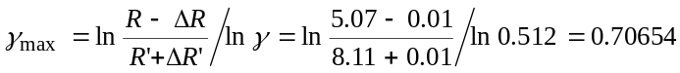

Smaller value of γ: 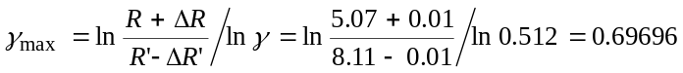

R = 5.07 kΩ | γ = 0.702
R’ = 8.11 kΩ | Δγ = 0.005

c)
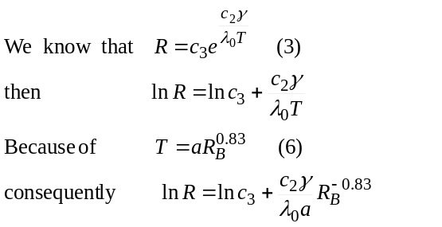

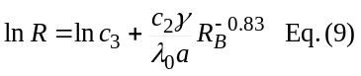

d)

V /V | I / mA | R_{B} / Ω | T / K | R_{B}^{-0.83} (S.I.) | R / kΩ | ln R
9.48 ± 0.01 | 85.5 ± 0.1 | 110.9 ± 0.2 | 1962 ± 18 | (2.008 ± 0.004)10⁻² | 8.77 ± 0.01 | 2.171 ± 0.001
9.73± 0.01 | 86.8 ± 0.1 | 112.1 ± 0.2 | 1980 ± 18 | (1.990± 0.004)10⁻² | 8.11 ± 0.01 | 2.093 ± 0.001
9.83± 0.01 | 87.3 ± 0.1 | 112.6 ± 0.2 | 1987 ± 18 | (1.983± 0.004)10⁻² | 7.90 ± 0.01 | 2.067 ± 0.001
10.01± 0.01 | 88.2 ± 0.1 | 113.5 ± 0.2 | 2000 ± 18 | (1.970± 0.004)10⁻² | 7.49 ± 0.01 | 2.014 ± 0.001
10.25± 0.01 | 89.4 ± 0.1 | 114.7 ± 0.2 | 2018 ± 18 | (1.952± 0.003)10⁻² | 7.00 ± 0.01 | 1.946 ± 0.001
10.41± 0.01 | 90.2 ± 0.1 | 115.4 ± 0.2 | 2028 ± 18 | (1.943± 0.003)10⁻² | 6.67 ± 0.01 | 1.894 ± 0.002
10.61± 0.01 | 91.2 ± 0.1 | 116.3 ± 0.2 | 2041 ± 18 | (1.930± 0.003)10⁻² | 6.35 ± 0.01 | 1.849 ± 0.002
10.72± 0.01 | 91.8 ± 0.1 | 116.8 ± 0.2 | 2049 ± 19 | (1.923± 0.003)10⁻² | 6.16 ± 0.01 | 1.818 ± 0.002
10.82± 0.01 | 92.2 ± 0.1 | 117.4 ± 0.2 | 2057 ± 19 | (1.915± 0.003)10⁻² | 6.01 ± 0.01 | 1.793 ± 0.002
10.97± 0.01 | 93.0 ± 0.1 | 118.0 ± 0.2 | 2066 ± 19 | (1.907± 0.003)10⁻² | 5.77 ± 0.01 | 1.753 ± 0.002
11.03± 0.01 | 93.3 ± 0.1 | 118.2 ± 0.2 | 2069 ± 19 | (1.904± 0.003)10⁻² | 5.69 ± 0.01 | 1.739 ± 0.002
11.27± 0.01 | 94.5 ± 0.1 | 119.3 ± 0.2 | 2085 ± 19 | (1.890± 0.003)10⁻² | 5.35 ± 0.01 | 1.677 ± 0.002
11.42± 0.01 | 95.1 ± 0.1 | 120.1 ± 0.2 | 2096 ± 19 | (1.880± 0.003)10⁻² | 5.15 ± 0.01 | 1.639 ± 0.002
11.50± 0.01 | 95.5 ± 0.1 | 120.4 ± 0.2 | 2101 ± 19 | (1.875± 0.003)10⁻² | 5.07 ± 0.01 | 1.623 ± 0.002
 |  |  | unnecessary

We work out the errors for all the first row, as example.

Error for R_{B}: 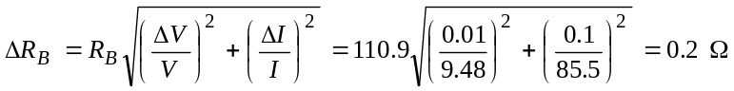

Error for T: 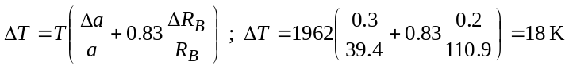

Error for R_{B}^{-0.83} :
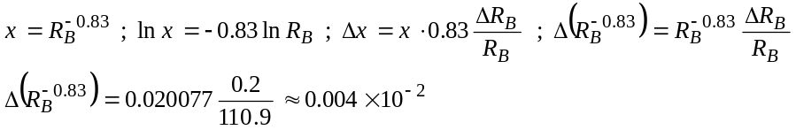

Error for lnR : 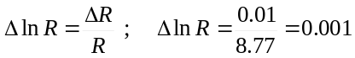

e)

We plot ln R versus R_{B}^{-0.83} .

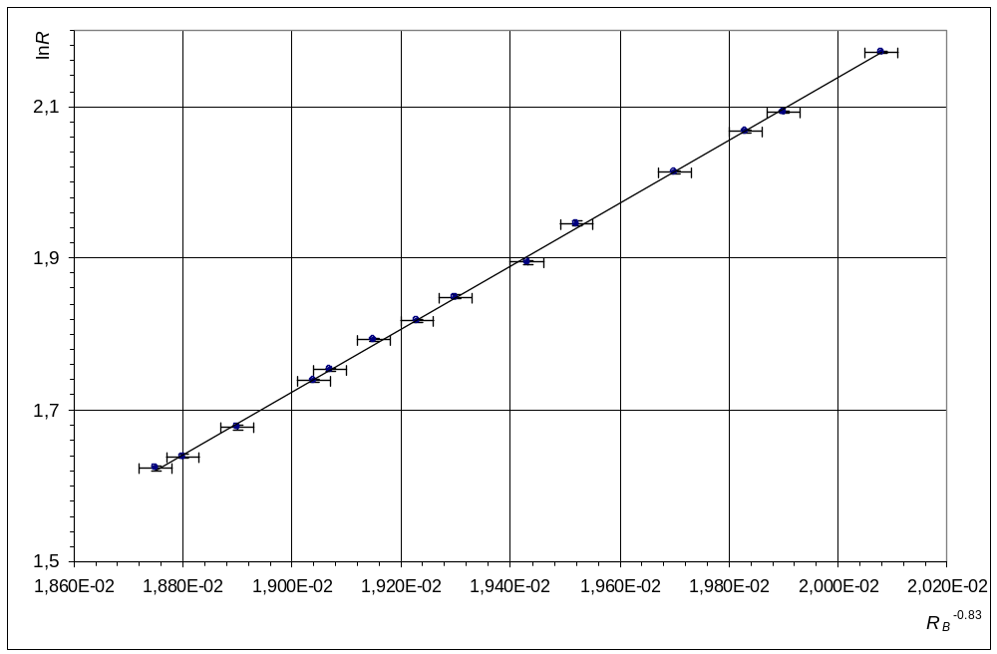

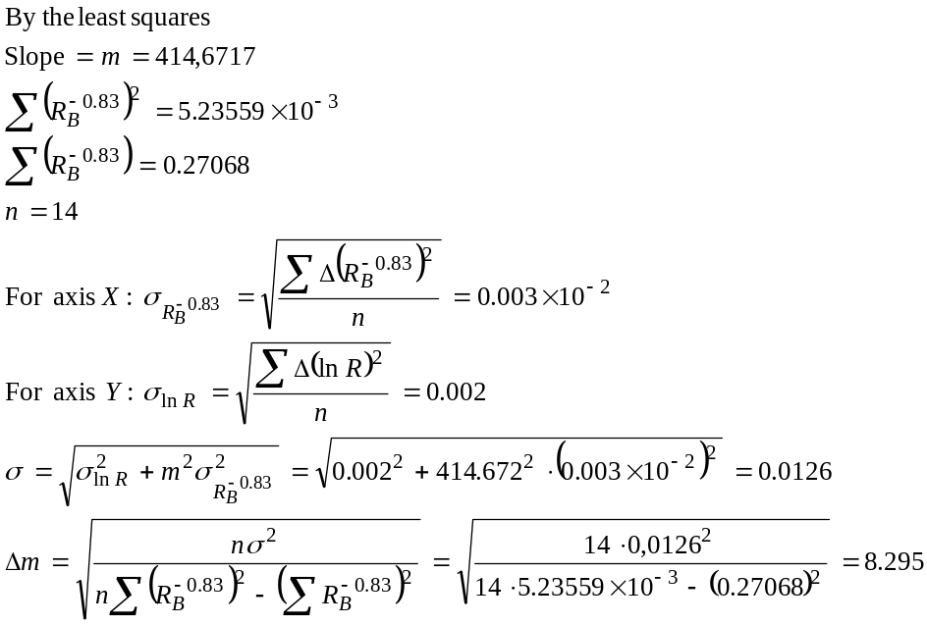

Because of
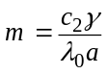
and
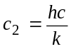
then
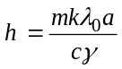

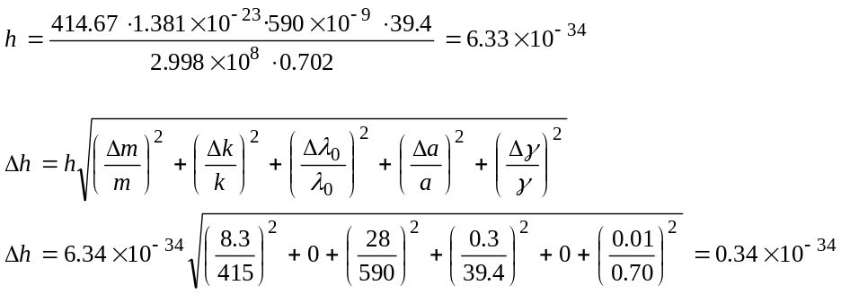

h = 6.3 × 10⁻³⁴ J · s | Δ h = 0.3 × 10⁻³⁴ J · s

